1-1: Cold Backup

1. Determine the location of your datafiles, control files, and online redo log files.

SQL> select name from v$datafile;

NAME
----------------------------------------------------------------
C:\MSCD642\DBMS\APP\ADMIN\BK202\ORADATA\DISK1\SYSTEM01.DBF
C:\MSCD642\DBMS\APP\ADMIN\BK202\ORADATA\DISK1\UNDOTBS01.DBF
C:\MSCD642\DBMS\APP\ADMIN\BK202\ORADATA\DISK2\SYSAUX01.DBF
C:\MSCD642\DBMS\APP\ADMIN\BK202\ORADATA\DISK2\USERS01.DBF

SQL> select member from v$logfile;

MEMBER
----------------------------------------------------------------
C:\MSCD642\DBMS\APP\ADMIN\BK202\ORADATA\DISK5\REDO03.LOG
C:\MSCD642\DBMS\APP\ADMIN\BK202\ORADATA\DISK4\REDO02.LOG
C:\MSCD642\DBMS\APP\ADMIN\BK202\ORADATA\DISK3\REDO01.LOG

SQL> select name from v$controlfile;

NAME
----------------------------------------------------------------
C:\MSCD642\DBMS\APP\ADMIN\BK202\ORADATA\DISK3\CTRL1.CTL
C:\MSCD642\DBMS\APP\ADMIN\BK202\ORADATA\DISK4\CTRL2.CTL
C:\MSCD642\DBMS\APP\ADMIN\BK202\ORADATA\DISK5\CTRL3.CTL

2. Shutdown your database.

SQL> shutdown immediate;
Database closed.
Database dismounted.
ORACLE instance shut down.

3. Copy the files identified in step one to a backup folder

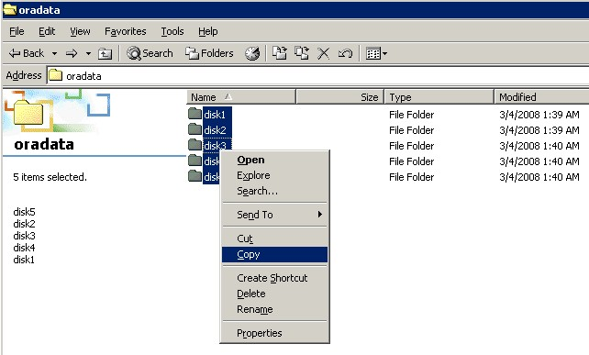

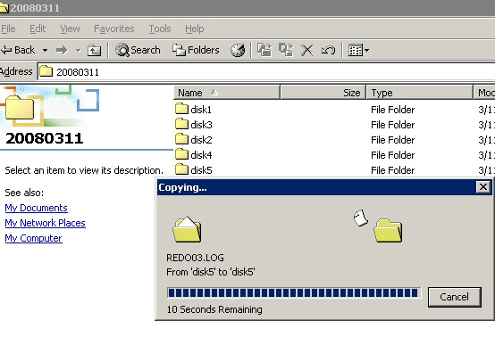

4. Startup your database.

SQL> startup
ORACLE instance started.

Total System Global Area 100663296 bytes
Fixed Size 1247492 bytes
Variable Size 58722044 bytes
Database Buffers 33554432 bytes
Redo Buffers 7139328 bytes
Database mounted.
Database opened.
1-1-2: Hot Backup

1. Create a folder named hotBackups

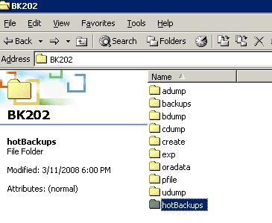

2. Determine the location of your datafiles

SQL> select name from v$datafile;

NAME
----------------------------------------------------------------
C:\MSCD642\DBMS\APP\ADMIN\BK202\ORADATA\DISK1\SYSTEM01.DBF
C:\MSCD642\DBMS\APP\ADMIN\BK202\ORADATA\DISK1\UNDOTBS01.DBF
C:\MSCD642\DBMS\APP\ADMIN\BK202\ORADATA\DISK2\SYSAUX01.DBF
C:\MSCD642\DBMS\APP\ADMIN\BK202\ORADATA\DISK2\USERS01.DBF

SQL> select member from v$logfile;

MEMBER
----------------------------------------------------------------
C:\MSCD642\DBMS\APP\ADMIN\BK202\ORADATA\DISK5\REDO03.LOG
C:\MSCD642\DBMS\APP\ADMIN\BK202\ORADATA\DISK4\REDO02.LOG
C:\MSCD642\DBMS\APP\ADMIN\BK202\ORADATA\DISK3\REDO01.LOG

SQL> select name from v$controlfile;

NAME
----------------------------------------------------------------
C:\MSCD642\DBMS\APP\ADMIN\BK202\ORADATA\DISK3\CTRL1.CTL
C:\MSCD642\DBMS\APP\ADMIN\BK202\ORADATA\DISK4\CTRL2.CTL
C:\MSCD642\DBMS\APP\ADMIN\BK202\ORADATA\DISK5\CTRL3.CTL

3. Ensure your database is in archivelog mode

SQL> select log_mode from v$database;

LOG_MODE
------------
NOARCHIVELOG

SQL> shutdown immediate
Database closed.
Database dismounted.
ORACLE instance shut down.
SQL> startup mount
ORACLE instance started.

Total System Global Area 100663296 bytes
Fixed Size 1247492 bytes
Variable Size 58722044 bytes
Database Buffers 33554432 bytes
Redo Buffers 7139328 bytes
Database mounted.
SQL> alter database archivelog;

Database altered.

SQL> alter database open;

Database altered.

SQL> select log_mode from v$database;

LOG_MODE
------------
ARCHIVELOG

4. SQL> alter database begin backup;

SQL> alter database begin backup;

Database altered.

5. Copy the files identified in step one to the hotBackups folder

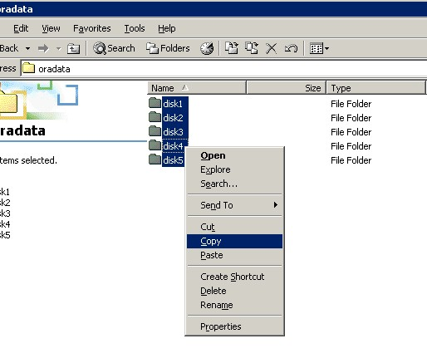
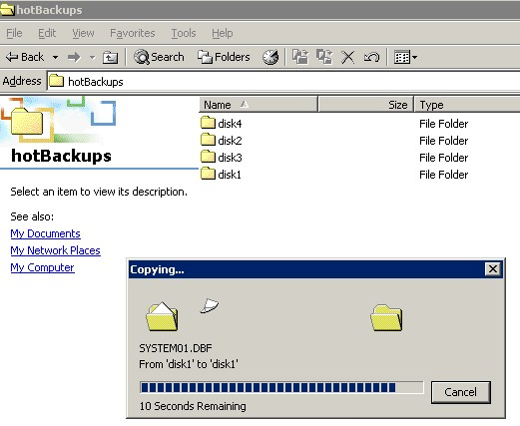

6. SQL> alter database end backup;

SQL> alter database end backup;

Database altered.

1-1-3 – Recipes 2-1 through 2-7
Recipe 2-1 – Connecting to your Database

Connect from command prompt
C:\>sqlplus sys/oracle@remote42202.world as sysdba

SQL*Plus: Release 10.2.0.1.0 - Production on Wed Mar 12 17:10:03 2008

Copyright (c) 1982, 2005, Oracle. All rights reserved.

Connected to an idle instance.

Recipe 2-2 – Starting and Stopping the Database

Startup Database
SQL> startup
ORACLE instance started.

Total System Global Area 100663296 bytes
Fixed Size 1247492 bytes
Variable Size 58722044 bytes
Database Buffers 33554432 bytes
Redo Buffers 7139328 bytes
Database mounted.
Database opened.

Shutdown Database
SQL> shutdown
Database closed.
Database dismounted.
ORACLE instance shut down.

Startup using Pfile
SQL> startup pfile=h:\dbms\app\admin\BK202\pfile\initBK202.ora
ORACLE instance started.

Total System Global Area 100663296 bytes
Fixed Size 1247492 bytes
Variable Size 58722044 bytes
Database Buffers 33554432 bytes
Redo Buffers 7139328 bytes
Database mounted.
Database opened.

Shutdown immediate
SQL> shutdown immediate
Database closed.
Database dismounted.
ORACLE instance shut down.

Recipe 2-3 – Toggling Archivelog Mode

Enable Archivelog Mode
Connect as sysdba
SQL> connect sys/oracle@remote42202.world as sysdba
Connected to an idle instance.

Shut down database
SQL> shutdown
Database closed.
Database dismounted.
ORACLE instance shut down.

Startup in mount mode
SQL> startup mount
ORACLE instance started.

Total System Global Area 100663296 bytes
Fixed Size 1247492 bytes
Variable Size 58722044 bytes
Database Buffers 33554432 bytes
Redo Buffers 7139328 bytes
Database mounted.

Alter database into archivelog mode
SQL> alter database archivelog;

Database altered.

Open your database for use
SQL> alter database open;

Database altered.

Disable Archivelog Mode
Shut database down (when still logged on as sysdba)
SQL> shutdown immediate;
Database closed.
Database dismounted.
ORACLE instance shut down.

Start database in mount mode
SQL> startup mount;
ORACLE instance started.

Total System Global Area 100663296 bytes
Fixed Size 1247492 bytes
Variable Size 58722044 bytes
Database Buffers 33554432 bytes
Redo Buffers 7139328 bytes
Database mounted.

Toggle to noarchivelog mode
SQL> alter database noarchivelog;

Database altered.

Open database
SQL> alter database open;

Database altered.

Display mode the database is in
SQL> select log_mode from v$database;

LOG_MODE
------------
NOARCHIVELOG

Recipe 2-4 – Connecting to RMAN
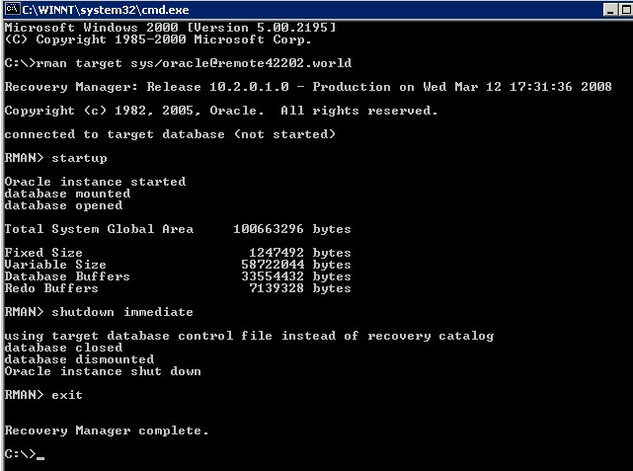
Recipe 2-5 – Backing up your database
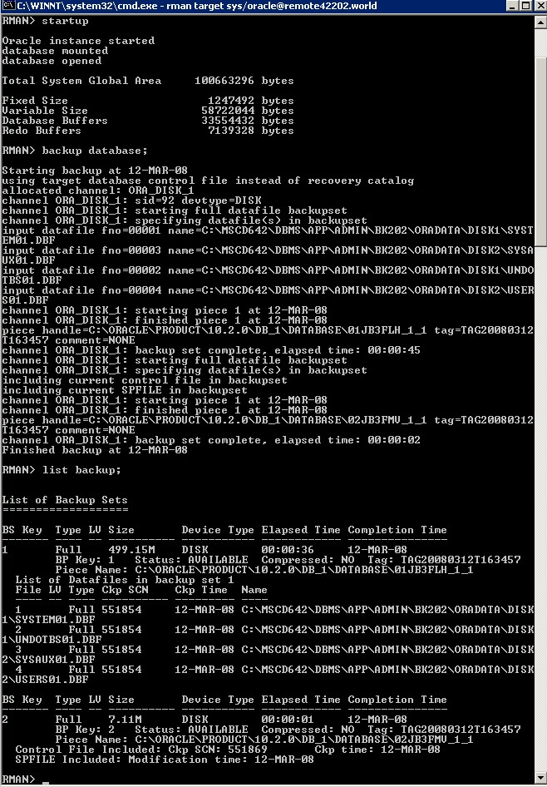
Recipe 2-6 – Simulating a failure
(I have a backup as noted by 2-5)
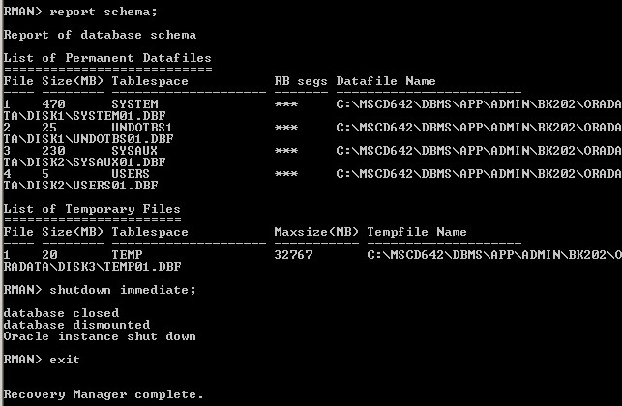
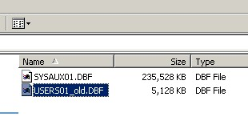
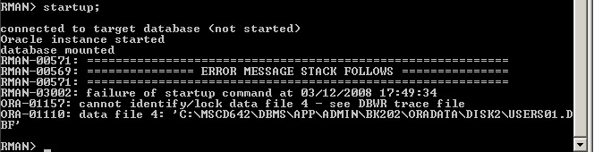
Recipe 2-7 – Restoring and Recovering Your Database
